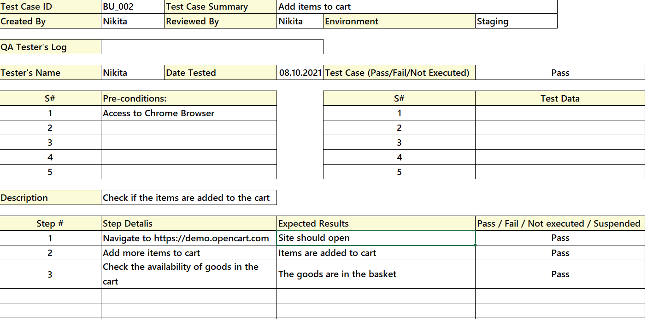

The causal technique is used for the second test case. That is, when you click on the Add (cause) button, the product is added to the cart (consequence).